Ullesthorpe C of E Primary School

Anti-Bullying Policy


Signed by the Governing Body:_______
Agreed by the Governing body: _______
Review date: _______or earlier if required

All children are a gift from God. They are all special and should be allowed to develop and grow
in a nurturing environment secure in the knowledge that they are cherished.

Bullying violates the value that each child and adult has. It is essential to affirm that each
person has the right to walk in freedom and security, to develop their full potential. Bullying is a denial of this basic right.

Statement of Intent

Pupils at Ullesthorpe C of E Primary School deserve an education in an environment which promotes high standards of teaching and learning. Our school expects a high level of behavior from both children and adults to support and enhance this environment. Where bullying takes place, children’s ability to learn can be restricted and their true potential limited. Children should feel confident talking about their problems with adults, and be fully aware of any planned actions to support them. At Ullesthorpe we seek to provide a safe, secure and positive environment in which children and adults can grow and develop, making full use of the range of facilities available to them.

All our children have the right to feel secure, to be able to trust without fear, and to expect protection from adults in positions of care and responsibility. They also have a basic right to take full part in their education in an environment that does not subject them to cruelty or create despair.

We are committed to a value system within which children and adults involved with them are entitled to be treated with respect and understanding and to participate without fear of intimidation. Any behaviour that undermines this is unacceptable.

It is recognised that the Head Teacher and Local Advisory Board have a statutory responsibility for school behaviour and discipline, but that all members of the school community accept collective responsibility for the successful implementation of this policy, including the pupils themselves. A staff champion, Kathy Leese, is responsible for leading Anti Bullying across the school.

Our School Pledge 2023, created by children and adults:

We pledge to stand up to Bullying and create a compassionate and empathetic school through our actions.

We will play safely and follow the school rules.

We will respect and appreciate difference in others and treat everyone equally

We will speak out against bullying behaviour and tell an adult straight away.

We will listen to others when they need help and show empathy.

Definition of Bullying

Friendship difficulties are a common part of growing up, however bullying is not simply a case of falling out with friends. Bullying arises out of a wish to hurt, threaten or frighten someone else.

Although there are a number of definitions of bullying, these definitions would include the following characteristics:

• It tends to be repetitive
• It involves an imbalance of power- physical or emotional.
• It is often motivated by prejudice against particular groups.

All members of our school community have the right to feel safe and secure, therefore this policy applies to children and school staff.

Our school’s definition of bullying is:

Bullying is the repetitive, intentional hurting of one person or group by another person or group, where the relationship involves an imbalance of power. It can happen face to face or online

We explain this to the children as ‘Several Times On Purpose’ and encourage children to ‘Start Telling Other People’.

2. Types of Bullying and Protected Characteristics

There are a number of different kinds of bullying not limited to:

Physical: Hitting, kicking, stealing, hiding belongings, inappropriate touching, anything physically unpleasant.

Verbal: Name-calling, insults, religious taunting, offensive remarks, teasing, using language, which is threatening, coercive, racist, sexist, homophobic. This includes attacks on non-English speakers, SEN pupils and those with a disability.

Emotional bullying: rumour spreading, malicious gossip, extortion, coercion of the harmed into acts he/she does not wish to do, intimidation, initiation or hazing violence, ostracising, spreading rumours or stories, graffiti, threatening or obscene gestures, inciting others to be unkind, excluding, isolating or ignoring another pupil.

Cyber: All areas of the internet such as email and internet chat room misuse, mobile phone threats by text messages or calls, misuse of associated technology i.e. camera and video facilities. It can be through distribution/possession of personal information/images about the victim. For further detail see ICT and Internet Acceptable Use policy.

Instigators may use different pretexts as the basis of their bullying, including the nine protected characteristics (age, disability, gender reassignment, marriage and civil partnership, pregnancy and maternity, race, religion or belief, sex and sexual orientation – See Appendix 1 Equality Act Poster), but particularly:

Racial, religious, cultural bullying - is where the motivation for bullying is based on the target's skin colour, culture, nationality or faith. Any incident perceived to be racist by the alleged victim or any other person. Incidents related to religion, culture or those involving pupils who identify as Gypsy/Roma traveller come under this heading too.

SEN and disability bullying - where an individual or group are targeted because of a special educational need or disability which includes learning difficulties, sensory impairments and mental health conditions.

Appearance or health conditions – where an individual or group are targeted because of their physical appearance or a health condition for example a disfigurement, a traumatic injury, severe skin condition. This includes individuals with a range of medical, mobility, sensory, mental health or learning impairments.

Home circumstance – where the motivation for bullying is based on the persons living arrangements for example: young carers, children in care or geographic locality i.e. where they live.

Homophobic and Biphobic bullying – relates to a person’s sexual orientation. It is based on prejudice or negative attitudes, beliefs or views about lesbian, gay or bi people. Individuals or groups can be targeted because of their actual or perceived sexuality. People who have lesbian, gay or bi family members can also be targeted as can students who do not conform to gender stereotypes.

Transphobic bullying – relates to gender identity. It is based on prejudice or negative attitudes, views or beliefs about trans people. Transphobic bullying affects people who are trans but can also affect those questioning their gender identity as well as people who are not trans but do not conform to gender stereotypes.

Sexual bullying – can relate to the target’s gender or body, this can have a sexual and/or sexist element. It can include intrusive language, damage to sexual reputation and unwanted sexual attention

Bullying Outside School Premises

The Preventing and Tackling Bullying Guidance from the DoE states:
Bullying can also occur outside the school gates and on journeys to and from school. Section 89(5) of the Education and Inspections Act 2006 gives head teachers a specific statutory power to regulate pupils’ conduct when they are not on school premises and are not under charge of a member of school staff.

Where a pupil, parent or member of the community tells us of bullying off the school premises we will investigate and act upon all information received as we would for an incident within the school grounds.This may include bullying incidents occurring anywhere off the school premises, such as on school or public transport, outside the local shops, or in a town or village centre. If the misbehaviour could be criminal or poses a serious threat to a member of the pubic, the head teacher will also notify the police.

3. Preventing Bullying

- How we proactively reduce incidents of bullying in school

As a school, we are determined to eradicate bullying of any kind. Bullying can sometimes be misunderstood as ‘falling out’ with other pupils, or a one-off disagreement so it is the job of the whole school to ensure that children understand what bullying is. We are a listening and telling school. This is the message that will be promoted at all times and with all audiences. There is an agreed collective responsibility to address any incidents of bullying observed. Throughout the year as a minimum, we invest time in the list below to achieve this.

- Break and Lunch time support staff trained in restorative behaviour techniques and report incidents straight to class teacher.

- Weekly PSHE lessons using the SCARF plans and resources. These include relationships education and specifically taught units to support children in their understanding of bullying

- Schools Assemblies that share with the whole school the Anti Bullying message.

- Participate in the National Anti-Bullying Week (November) and The “Beyond Bullying” Award Scheme.

- Internet Safety Week to make children aware of the dangers of cyber bullying.

- Train Well Being Ambassadors to support our children in the event of bullying.

- Train Well Being Staff Ambassadors to support adults in the event of bullying.

- Anti-bullying training for Governors and relevant staff plus in house staff training to ensure school adults are aware and kept up to date with the guidance on bullying.

- Within school, we actively promote a culture where children are encouraged to ‘tell’ an adult on their support network, without fear of reprisals. We use restorative justice techniques to address behaviour concerns

- This policy will be discussed with all pupils and be made available to parents on request. This is to ensure that all pupils understand the school’s policy of zero tolerance of bullying and their role in making it a success.

- The School Council will include bullying as an agenda item regularly.

- Incidents will be logged and monitored on a termly basis by the Head Teacher. The information will be given to the Governing body each term as part of the Head Teachers Report and shared with members of the teaching staff as and when deemed appropriate

- How we deal with allegations of Bullying.
Bullying allegations can come from a number of different sources including from the child, child’s friends, parent/carer or staff member. All allegations will be listened to, taken seriously and acted upon.
Three issues will be addressed:
Challenge | Speak to targeted pupil(s) and perpetrator(s) privately explaining why bullying is not acceptable. Work with instigator(s) to change behaviours.  Talk to parents/carers of all families.  A combination of direct sanctions (Withdrawal from class/play areas) and restorative approaches are used. Restorative behaviour techniques are detailed in our Restorative Well-being and Behaviour Policy. If a child is repeatedly involved in bullying other children and initial discussions have proven ineffective, the headteacher may contact external support agencies. Persistence may result in exclusion.
Comfort | Comfort the targeted pupil(s) and discuss different ways in which you or the school can help.  Talk to parents/carers. Find out what sort of support they want.  Help pupil(s) to contact peer anti-bullying support groups or access outside support.  Monitor the situation and follow up accordingly.
Report | Report the incident to the headteacher.  Make sure that everyone else who needs to know, such as class teachers, teaching assistants, lunchtime supervisors and the head teacher are aware.

When talking about the incident, we will use the following language: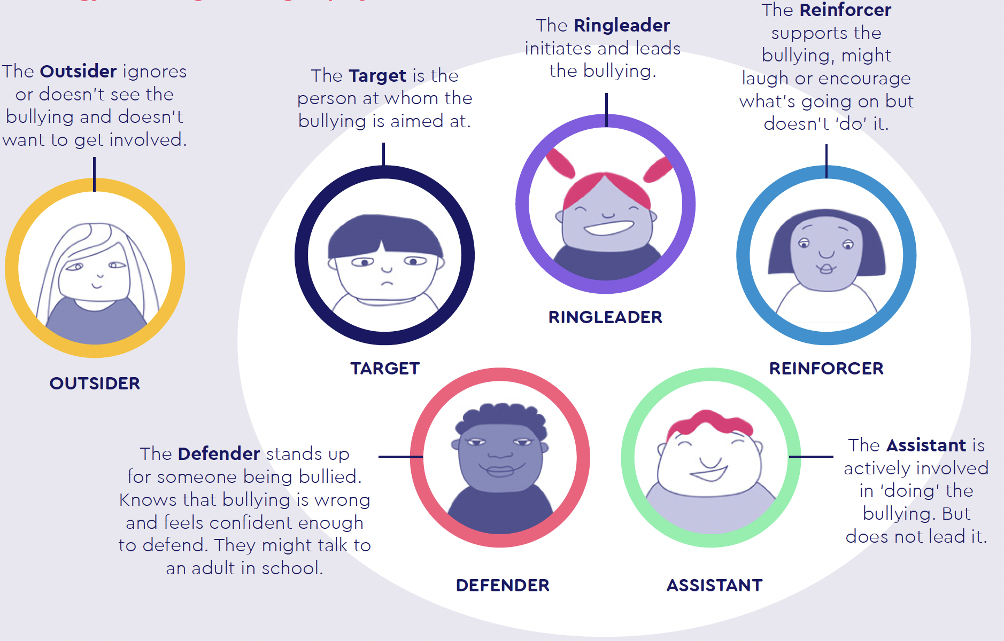
- How we record and report Bullying incidents.

All bullying and hate incidents are recorded by staff. Dates, times and anything said by all children involved will be recorded for future reference. We use the Arbor system to do this. The head teacher will report incidents to the Governing Body on a termly basis. The head teacher is responsible for coordinating and monitoring the recording system, and analysing data. Staff will then use this data to discuss next steps for the school as well as to inform individual class planning of lessons. Where children require specific support, risk assessments or personal plans will be developed to prevent the repetition of bullying behaviour.

Prejudice Driven Incidents

A prejudice related incident is one involving for example racist graffiti or sexist language, which needs to be addressed but may not constitute bullying because it is not repeated, not intentional or not directed at an individual. It involves the protected characteristics in the Equality Act 2010 (See Appendix 1)
These incidents often involve the same behaviour as that included in the ‘types of bullying’ section. Our school actively promotes equality and cohesion and therefore operates a zero tolerance approach to all forms of bullying and prejudice related incidences.

Prejudice driven incidents involving protected characteristics, such as racism or homophobia, will be logged separately as a Level 3 incident on the Arbor System. This is the highest level incident on the system.

4. Additional Information

Bullying of staff by pupils, parents/carers or other adults.

Bullying can occur between adults. Bullying tactics are sometimes employed in business;
relationships between members of staff are sometimes characterised by bullying. Parents, carers, teachers and other adults sometimes bully children and vice versa. Staff are sometimes bullied by parents / carers. Staff as well as children benefit if school establishes an ethos that repudiates bullying. The senior leaders and governors of the school strive to support the emotional health and well being of the staff in the school and so we believe that all bullying incidents must be investigated.
This includes any incident reported by a member of staff or being bullied by a child and or parent carer. Members of the school workforce suffering from or concerned about bullying can also contact their trade union or professional association for support and advice.

Involving Parents
The school has an open door policy and class teachers and/or the head teacher will strive to speak with parents / carers to discuss any concerns immediately. Parental involvement in the response process has been outlined in the Response to Bullying section above. Parental questionnaires will be sent out when appropriate to collect views on the impact of policy and practice. Newsletters will outline strategies we have put in place to maximise the family ethos of the school.

Anti Bullying Complaints

If parents / carers are unhappy about the way that an alleged bullying incident has been handled they should in the first instance speak with the class teacher or head teacher. There is a School Complaints procedure if parents / carers are still concerned. Parents / carers will be advised of this procedure by the head teacher and a copy will be made available from the school office.

Monitoring and Evaluating the Policy

● The policy will be part of the everyday life of the school. It will be maintained regularly through display of posters, PSHE and curriculum tasks.
● Assemblies
● It will be a regular item on School Council Agendas, at staff and Governors’ meetings.
● Its effectiveness will be monitored through parent, pupil and staff questionnaires and
reported incidents.

Appendix 1

